QuArk Map Editor for Mahatta Tutorial

Your First Map

Creating a new default map

With the QuArk main window open, click on Toolboxes, then New Files… This will open a new window. Double click on Map and this will generate a new map with a default room.

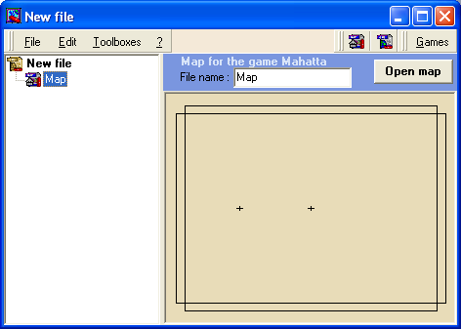

To start editing, open the map by pressing the Open map. This will take you to the map editing window.

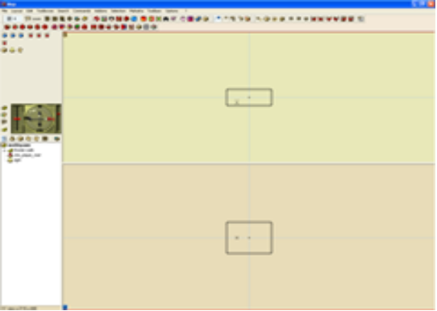

If you do not want the QuArk default view, you can change it by going to Layout and selecting a style from the very bottom: classic layout, 3 view (2D) layout…etc.
Building the new default map

To try out the map in Mahatta, you must build the map to create a .BSP file for Mahatta to use.

Click on Mahatta at the topmost menu and then click on GO!. This will create the .BSP file, build the vis table, calculate the lighting and then run Mahatta with the map. For further explanation, see the build manual.

Once Mahatta starts, you are able to run around the newly create map.

Using QuArk

For the rest of the tutorial, follow the tutorial section of QuArk. Mostly look into the whole section 2.1. Remember to keep practice!

